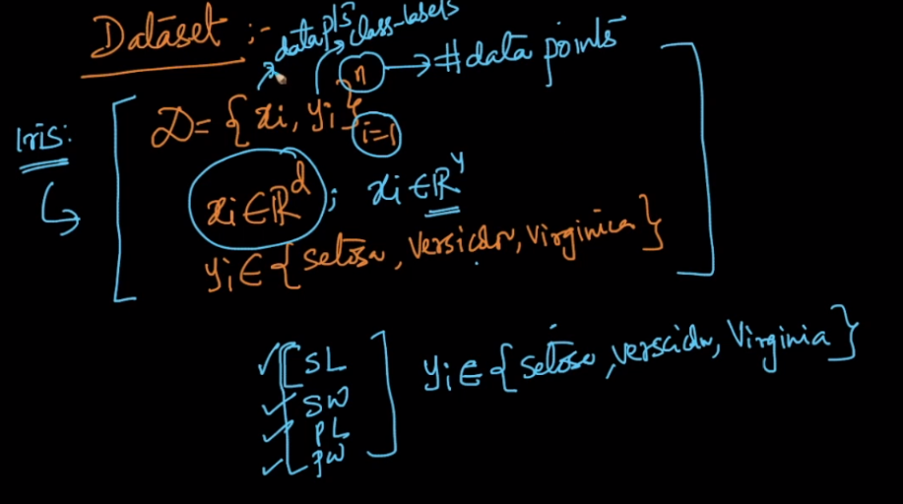

Given D = { xi , yi } n i=1

Here xi belongs to Rd(here d is dimensions, for iris it’s 4), for example here xi is the column vector, for iris dataset x1 will be [1, 4, 6, 4] each is SL, SW, PL, PW.

And yi belongs to any of the class label that is for iris it may be **setossa, versicolor, virginica.**

In a dataset D = {x,y}, 'x' represents the input vector and 'y' represents the output label/value.

**Comments:**

* For a single value, X will be a column vector and y will be a single value. But for an entire dataset X will be a matrix and Y will be a column vector.

Example:

that means for a datapoint y_i belong to real number and is a scalar value not a vector ; for example :

(xi,yi) where xi = (height,weight,age) ; yi = gender{0:Male;1:Female} , so lets say xi(179cm,75kg,24) ; yi(0)

. But if we consider all the n points then Y is a column vector of size n

* As we represent all the data points as R^d and writing it as xi ?R^d, what will be the representation for all the class label ? y?

In case of regression problem : y ? R  
In case of binary classification problem: y ? {0,1}